ASAP Model Building: F2018 with split NEFSC trawls survey series; ALB and BIG indices
The NEFSC winter (1992-2007), spring (1982-2017) and fall (1982-2016) bottom trawl surveys are among the research survey time series used to calibrate the current F2018 ASAP population model. The surveys were conducted using the FSV Albatross IV (ALB; with some intermittent substitution of the FSV Delaware II) until 2008 and the FSV Henry B. Bigelow (BIG) since 2009. A change in nets and towing protocol for the BIG resulted in potential changes in catchability for the spring and fall surveys, and several hundred comparison tows were made during 2008-2009 (both during the regular survey work and on special cruises) to develop calibration coefficients on aggregate number, aggregate weight, and on number at length bases to allow conversion of the BIG survey indices to ALB equivalents (Miller et al. 2010). The current (existing) F2018 (2 fleets) assessment model uses the NEFSC spring and fall ALB equivalent survey catch in relative aggregate numbers and numbers at age index forms.
A model run (F2018_BIGSV) was configured with separate spring and fall ALB (1982-2008) and BIG (2009-2017) time series of relative indices (i.e. stratified mean number per tow at age and in aggregate). All other model input data and settings remained the same as in the F2018 (2 fleets) run. Evaluation of the NEFSC spring and fall catchability coefficient (q) estimates for these relative indices of abundance provides a diagnostic of model uncertainty due to the use of the calibration factors, by comparison of the resulting ratio of BIG to ALB estimated q with the calibration factors.
Industry cooperative ‘twin trawl sweep study’ cruises were conducted during 2015-2017 in an attempt to better understand the behavior and performance of the BIG survey gear for a suite of bottom-tending species, including summer flounder. Preliminary results (T. Miller NEFSC personal communication 2017) from analyses of those data indicate that the average catch efficiency of the BIG gear for summer flounder is about 0.56 (i.e., 56% of the summer flounder encountered by the BIG gear are retained by the net). Averaged over day and night tows, the BIG catch efficiency is about 0.02 at 15 cm, increases to 0.50-0.60 from 32 cm to 60 cm, and increases further to 0.95 at 77 cm.
The ‘sweep study’ work also indicates that herding of fish by the BIG ground cables (wire between the wing end of the net and the trawl doors) and the trawl doors gear is likely to be low, and so the wing spread of the BIG gear (39.4 feet = 12.0 meters) is considered the appropriate dimension to use for swept area calculations. The current standard BIG area swept per tow is 0.00647931 square nautical miles (sqnm). The average values of BIG efficiency at length were first used to convert ‘standard’ catch per tow (Table A49) to ‘absolute’ catch per tow (Table A50). Next, the net dimensions and the annual spring and fall total survey coverage area (usually about 27,855 sqnm for the spring and 17,924 sqnm for the fall) were used to compute BIG indices as Swept Area Numbers (SWAN), or absolute estimates of stock numbers at age and in aggregate (Tables A51-A52). These estimates were used in another run, F2018_BIGSWAN, to further evaluate the catchability coefficients estimated for the NEFSC spring and fall surveys and as a diagnostic for the ‘scaling’ of the model stock size estimates, with the expectation that on the absolute scale, the q estimates are expected be less than or equal to 1.
A comparison of the NEFSC surveys estimated qs and ratios of interest for the F2018, F2018_BIGSV, and F2018_BIGSWAN runs are presented in the table below.

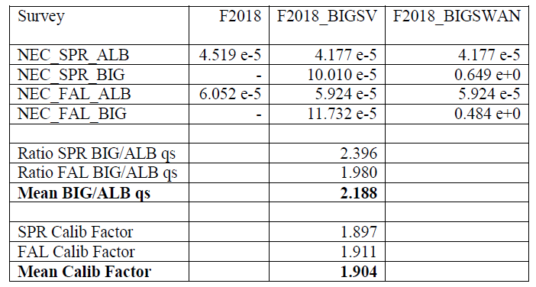

The mean of the F2018_BIGSV run NEFSC spring and fall survey ALB and BIG qs is about 2.2. The mean of the spring and fall length-based calibration factors used to convert the BIG indices into ALB equivalents for the indices used in the current F2018 model is about 1.9. Therefore, the F2018_BIGSV qualitatively returns the same BIG to ALB catch ratio (i.e., numeric calibration factor of about 2) as the calibration experiment factor. Figures A124-A125 compare some results from the F2018 and F2018_BIGSV runs. The F estimates are very similar. The SSB estimates are generally slightly higher for the F2018_BIGSV run since about 2000. Most of the SSB difference is due to higher stock size estimates at the older ages. The estimates at model age 1 (recruitment at true age 0) are very similar, while the largest differences occur for model age 8+ (true age 7+) since 2000.
As noted in TOR 2, application of the experimental ‘sweep study’ BIG efficiencies at length changes the computed catch per tow of the indices and, for the fall numeric indices, changes the rank order of the annual indices (i.e., 2016 is the highest in the 2019-2017 series; Figures A27-A28), so the BIG indices in the F2018_BIGSWAN run are slightly different than those in the F2018_BIGSV run. Therefore, the F2018_BIGSV and F2018_BIGSWAN configurations do have minor differences in their results.
The NEFSC BIG trawl survey absolute abundance estimates used in the F2018_BIGSWAN run are dependent not only on the results and assumptions from the twin trawl sweep study, but also those assumptions included in the expansion calculations (i.e., trawl wing swept area, no door herding, no escape about the head rope, sufficient sampling to assume the survey index is applicable to the entire survey area, etc.). The resulting q estimates from the BIGSWAN run (mean = (0.649+0.484)/2) = 0.567; see text table above) indicate that for this particular model configuration the NEFSC BIG trawl surveys on average ‘count’ about 60% of the total stock numbers.

